**HandsOn 7**

1. Create a new dotnet core project

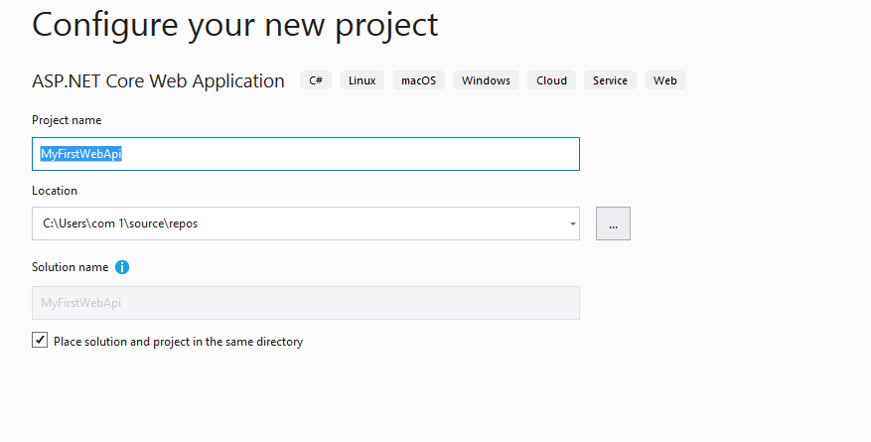

1. Select web api with docker support enabled.

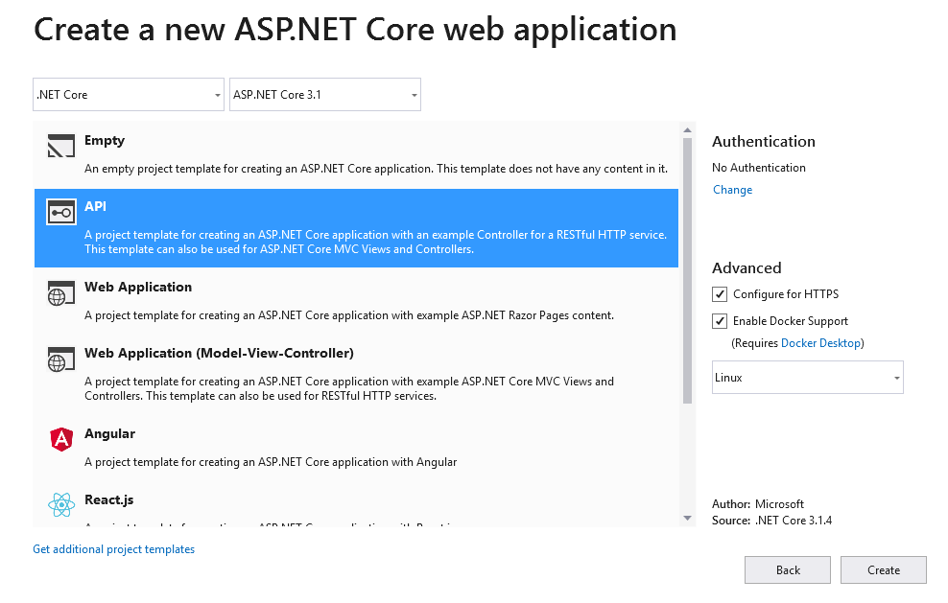

1. Push the code to the git

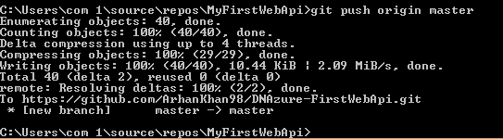

1. Select the devops starter in azure portal

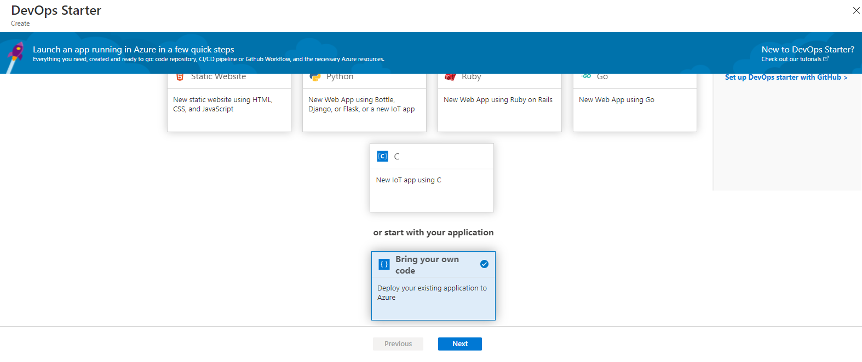

1. Select the repository from the github

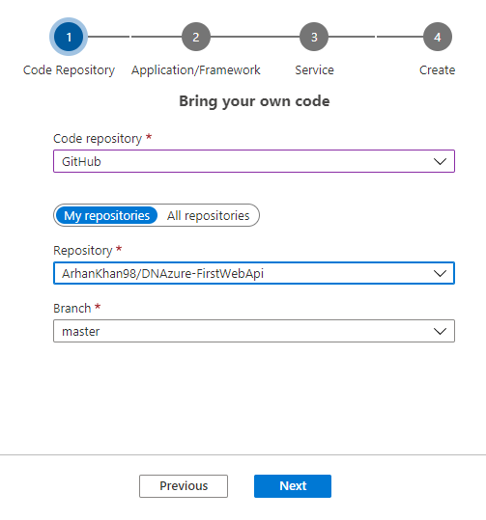

1. Select framework as dotnet core

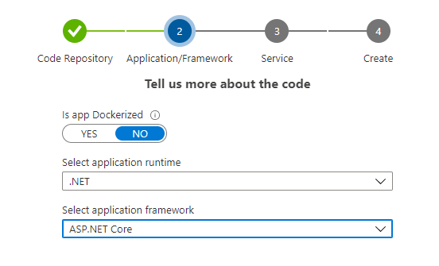

1. Select azure service

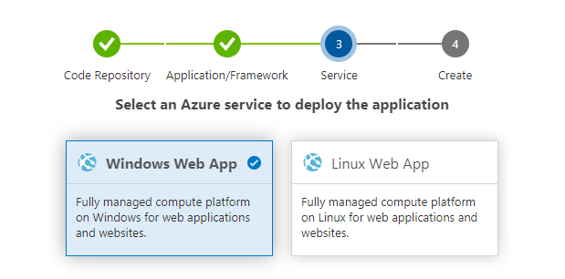

1. Give project name and create

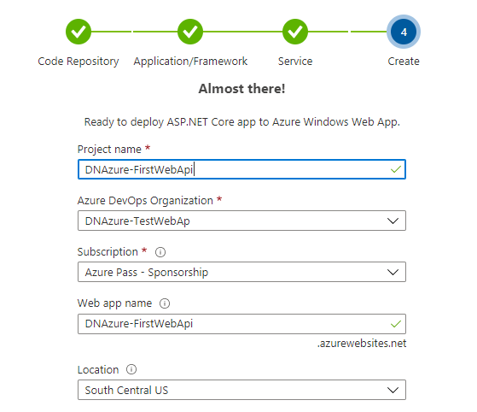

1. Change the Configuration from Standard to B1 basic

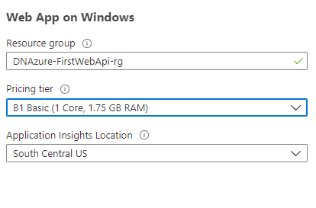

1. Go to resources and select build pipeline to view the task being executed

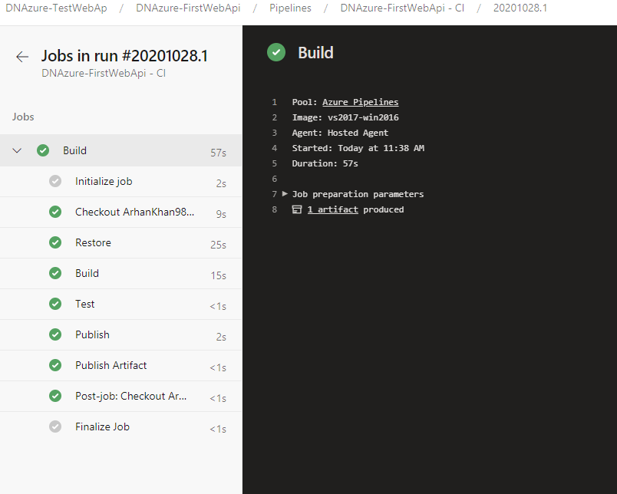

1. Select the release to see the release operation

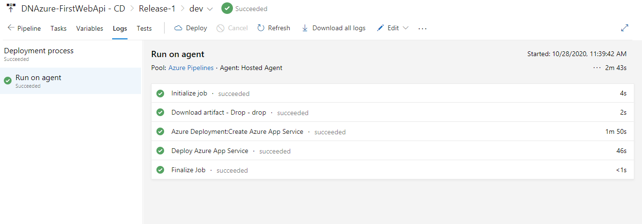

1. Go to home and click on the link

